https://jira.tcsbank.ru/browse/IN-394
Установка ОС Ubuntu на сервер ds-spl-indexer по SD#4312941
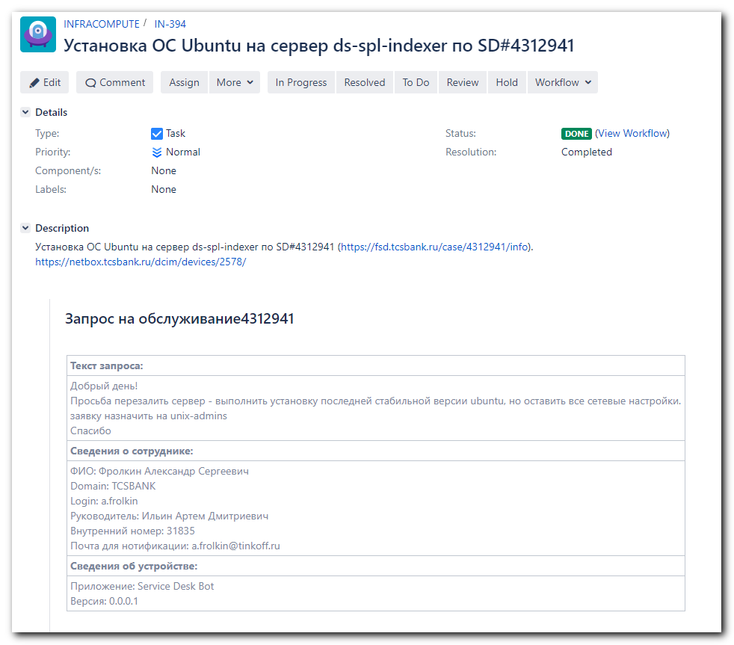

https://wiki.tcsbank.ru/pages/viewpage.action?spaceKey=TECHSUPPORT&title=Nexus+Unix+Team+Repository&refresh=1596712017779&focusedCommentId=712997892&refresh=1597055988075
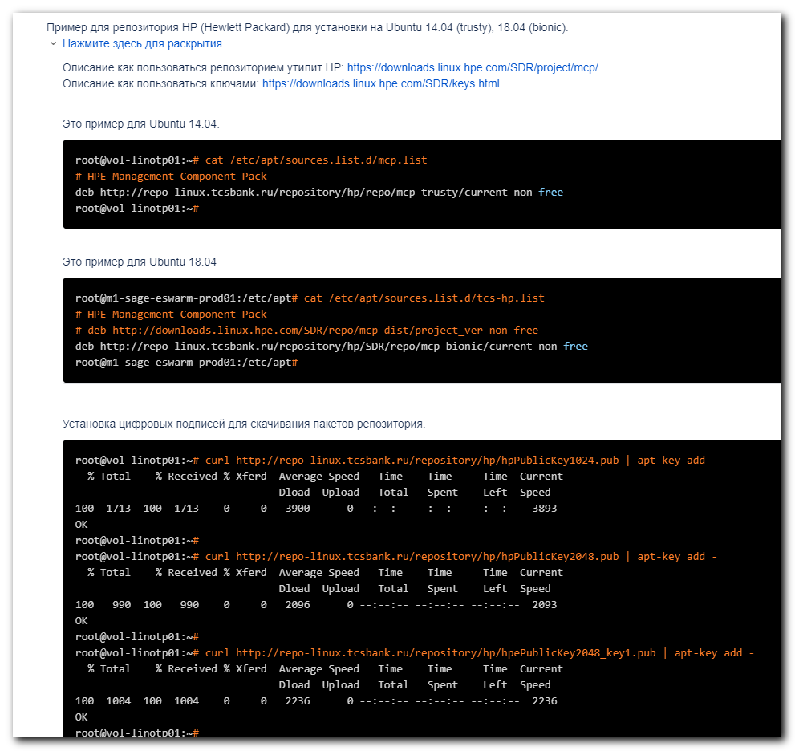

https://docs.google.com/document/d/1hCcKOYFe2QF1RrJrosqF_CU9ojJBKTwzXhCWLjIa8CU/edit
20171222 Configure Ubuntu 16.04 on HP server - snmp and nrpe
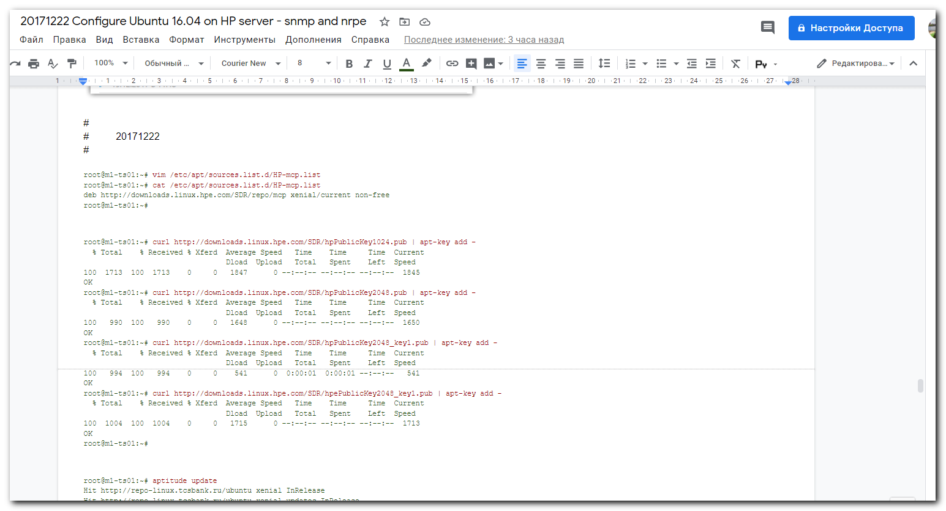

https://downloads.linux.hpe.com/SDR/project/mcp/
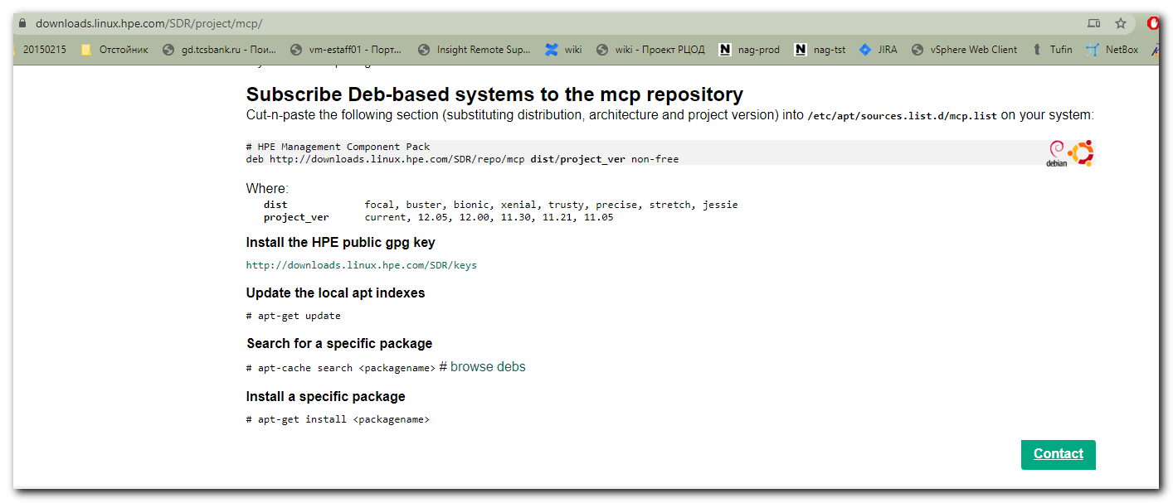

root@ds-spl-indexer:~# dmidecode -t system
# dmidecode 3.1
Getting SMBIOS data from sysfs.
SMBIOS 2.7 present.

Handle 0x0100, DMI type 1, 27 bytes
System Information
Manufacturer: HP
Product Name: ProLiant DL380 G7
Version: Not Specified
Serial Number: GB803550KE
UUID: 39333835-3431-4247-3830-333535304B45
Wake-up Type: Power Switch
SKU Number: 583914-B21
Family: ProLiant

Handle 0x2000, DMI type 32, 11 bytes
System Boot Information
Status: No errors detected

root@ds-spl-indexer:~#

root@ds-spl-indexer:~# vim /etc/apt/sources.list.d/tcs-hp.list

#
# I put this here at the first time.
#
root@m1-sage-eswarm-prod01:/etc/apt# cat /etc/apt/sources.list.d/tcs-hp.list
# HPE Management Component Pack
# deb http://downloads.linux.hpe.com/SDR/repo/mcp dist/project_ver non-free
deb http://repo-linux.tcsbank.ru/repository/hp/SDR/repo/mcp bionic/current non-free
root@m1-sage-eswarm-prod01:/etc/apt#

root@ds-spl-indexer:~# apt-get update
E: Type '.nagement' is not known on line 1 in source list /etc/apt/sources.list.d/tcs-hp.list
E: The list of sources could not be read.
root@ds-spl-indexer:~# vim /etc/apt/sources.list.d/tcs-hp.list
root@ds-spl-indexer:~# apt-get update
Hit:1 http://repo-linux.tcsbank.ru/ubuntu bionic InRelease
Hit:2 http://repo-linux.tcsbank.ru/ubuntu bionic-updates InRelease
Hit:3 http://repo-linux.tcsbank.ru/ubuntu bionic-backports InRelease
Hit:4 http://repo-linux.tcsbank.ru/ubuntu bionic-security InRelease
Ign:5 http://repo-linux.tcsbank.ru/repository/hp/SDR/repo/mcp bionic/current InRelease
Hit:6 http://repo-linux.tcsbank.ru/puppetlabs/apt bionic InRelease
Get:7 http://repo-linux.tcsbank.ru/repository/hp/SDR/repo/mcp bionic/current Release [6,051 B]
Get:8 http://repo-linux.tcsbank.ru/repository/hp/SDR/repo/mcp bionic/current Release.gpg [490 B]
Ign:8 http://repo-linux.tcsbank.ru/repository/hp/SDR/repo/mcp bionic/current Release.gpg
Reading package lists... Done
W: GPG error: http://repo-linux.tcsbank.ru/repository/hp/SDR/repo/mcp bionic/current Release: The following signatures couldn't be verified because the public key is not available: NO_PUBKEY C208ADDE26C2B797
E: The repository 'http://repo-linux.tcsbank.ru/repository/hp/SDR/repo/mcp bionic/current Release' is not signed.
N: Updating from such a repository can't be done securely, and is therefore disabled by default.
N: See apt-secure(8) manpage for repository creation and user configuration details.
root@ds-spl-indexer:~# curl http://repo-linux.tcsbank.ru/repository/hp/hpPublicKey1024.pub | apt-key add -
% Total % Received % Xferd Average Speed Time Time Time Current
Dload Upload Total Spent Left Speed
100 1713 100 1713 0 0 1528 0 0:00:01 0:00:01 --:--:-- 1528
OK
root@ds-spl-indexer:~# curl http://repo-linux.tcsbank.ru/repository/hp/hpPublicKey2048.pub | apt-key add -
% Total % Received % Xferd Average Speed Time Time Time Current
Dload Upload Total Spent Left Speed
100 990 100 990 0 0 2239 0 --:--:-- --:--:-- --:--:-- 2239
OK
root@ds-spl-indexer:~# curl http://repo-linux.tcsbank.ru/repository/hp/hpePublicKey2048_key1.pub | apt-key add -
% Total % Received % Xferd Average Speed Time Time Time Current
Dload Upload Total Spent Left Speed
100 1004 100 1004 0 0 1927 0 --:--:-- --:--:-- --:--:-- 1923
OK
root@ds-spl-indexer:~#

root@ds-spl-indexer:~# apt-get update
Hit:1 http://repo-linux.tcsbank.ru/ubuntu bionic InRelease
Hit:2 http://repo-linux.tcsbank.ru/ubuntu bionic-updates InRelease
Hit:3 http://repo-linux.tcsbank.ru/ubuntu bionic-backports InRelease
Hit:4 http://repo-linux.tcsbank.ru/ubuntu bionic-security InRelease
Ign:5 http://repo-linux.tcsbank.ru/repository/hp/SDR/repo/mcp bionic/current InRelease
Hit:6 http://repo-linux.tcsbank.ru/puppetlabs/apt bionic InRelease
Get:7 http://repo-linux.tcsbank.ru/repository/hp/SDR/repo/mcp bionic/current Release [6,051 B]
Get:8 http://repo-linux.tcsbank.ru/repository/hp/SDR/repo/mcp bionic/current Release.gpg [490 B]
Get:9 http://repo-linux.tcsbank.ru/repository/hp/SDR/repo/mcp bionic/current/non-free i386 Packages [525 B]
Get:10 http://repo-linux.tcsbank.ru/repository/hp/SDR/repo/mcp bionic/current/non-free amd64 Packages [2,192 B]
Fetched 9,258 B in 1s (7,573 B/s)
Reading package lists... Done
root@ds-spl-indexer:~#

................................................................................
#
# As we can see there are no appropriate packages in added repository.
# For some of packages HP changed its name. Other packages are absent at all.
#
root@ds-spl-indexer:~# apt-get install hp-health hponcfg hp-snmp-agents hpsmh hp-smh-templates hpssacli hp-ams hpssa hpssacli hpssaducli
Reading package lists... Done
Building dependency tree
Reading state information... Done
Package hpssa is not available, but is referred to by another package.
This may mean that the package is missing, has been obsoleted, or
is only available from another source
However the following packages replace it:
ssa

Package hpssacli is not available, but is referred to by another package.
This may mean that the package is missing, has been obsoleted, or
is only available from another source
However the following packages replace it:
ssacli

Package hpssaducli is not available, but is referred to by another package.
This may mean that the package is missing, has been obsoleted, or
is only available from another source
However the following packages replace it:
ssaducli

E: Unable to locate package hp-health
E: Unable to locate package hp-snmp-agents
E: Unable to locate package hpsmh
E: Unable to locate package hp-smh-templates
E: Package 'hpssacli' has no installation candidate
E: Unable to locate package hp-ams
E: Package 'hpssa' has no installation candidate
E: Package 'hpssacli' has no installation candidate
E: Package 'hpssaducli' has no installation candidate
root@ds-spl-indexer:~#

# Here I installed three common packages, that changed its name.
#
root@ds-spl-indexer:~# apt-get install ssa ssacli ssaducli
Reading package lists... Done
Building dependency tree
Reading state information... Done
The following packages were automatically installed and are no longer required:
facter fonts-lato hiera javascript-common libboost-filesystem1.65.1 libboost-locale1.65.1 libboost-log1.65.1 libboost-program-options1.65.1 libboost-regex1.65.1
libboost-system1.65.1 libboost-thread1.65.1 libcpp-hocon0.1.6 libfacter3.10.0 libjs-jquery libleatherman-data libleatherman1.4.0 libopts25 libruby2.5 libyaml-cpp0.5v5
python-argcomplete python-ipaddr rake ruby ruby-augeas ruby-deep-merge ruby-did-you-mean ruby-json ruby-minitest ruby-net-telnet ruby-power-assert ruby-selinux
ruby-shadow ruby-test-unit ruby2.5 rubygems-integration sntp
Use 'apt autoremove' to remove them.
The following NEW packages will be installed:
ssa ssacli ssaducli
0 upgraded, 3 newly installed, 0 to remove and 23 not upgraded.
Need to get 21.6 MB of archives.
After this operation, 0 B of additional disk space will be used.
Get:1 http://repo-linux.tcsbank.ru/repository/hp/SDR/repo/mcp bionic/current/non-free amd64 ssa amd64 4.17-6.0 [8,152 kB]
Get:2 http://repo-linux.tcsbank.ru/repository/hp/SDR/repo/mcp bionic/current/non-free amd64 ssacli amd64 4.17-6.0 [10.7 MB]
Get:3 http://repo-linux.tcsbank.ru/repository/hp/SDR/repo/mcp bionic/current/non-free amd64 ssaducli amd64 4.17.6-0 [2,787 kB]
Fetched 21.6 MB in 1min 20s (270 kB/s)
Selecting previously unselected package ssa.
(Reading database ... 124904 files and directories currently installed.)
Preparing to unpack .../ssa_4.17-6.0_amd64.deb ...
Unpacking ssa (4.17-6.0) ...
Selecting previously unselected package ssacli.
Preparing to unpack .../ssacli_4.17-6.0_amd64.deb ...
Unpacking ssacli (4.17-6.0) ...
Selecting previously unselected package ssaducli.
Preparing to unpack .../ssaducli_4.17.6-0_amd64.deb ...
Unpacking ssaducli (4.17.6-0) ...
Setting up ssacli (4.17-6.0) ...
Setting up ssaducli (4.17.6-0) ...
Setting up ssa (4.17-6.0) ...
Processing triggers for man-db (2.8.3-2ubuntu0.1) ...
root@ds-spl-indexer:~#

................................................................................
# This is not needed, I suppose.
root@ds-spl-indexer:~# apt-get install aptitude
Reading package lists... Done
Building dependency tree
Reading state information... Done
The following packages were automatically installed and are no longer required:
facter fonts-lato hiera javascript-common libboost-locale1.65.1 libboost-log1.65.1 libboost-program-options1.65.1 libboost-regex1.65.1 libboost-thread1.65.1
libcpp-hocon0.1.6 libfacter3.10.0 libjs-jquery libleatherman-data libleatherman1.4.0 libopts25 libruby2.5 libyaml-cpp0.5v5 python-argcomplete python-ipaddr rake ruby
ruby-augeas ruby-deep-merge ruby-did-you-mean ruby-json ruby-minitest ruby-net-telnet ruby-power-assert ruby-selinux ruby-shadow ruby-test-unit ruby2.5
rubygems-integration sntp
Use 'apt autoremove' to remove them.
The following additional packages will be installed:
aptitude-common libboost-iostreams1.65.1 libcgi-fast-perl libcgi-pm-perl libclass-accessor-perl libcwidget3v5 libencode-locale-perl libfcgi-perl libhtml-parser-perl
libhtml-tagset-perl libhttp-date-perl libhttp-message-perl libio-html-perl libio-string-perl liblwp-mediatypes-perl libparse-debianchangelog-perl libsigc++-2.0-0v5
libsub-name-perl libtimedate-perl liburi-perl libxapian30
Suggested packages:
aptitude-doc-en | aptitude-doc apt-xapian-index debtags libcwidget-dev libdata-dump-perl libhtml-template-perl libxml-simple-perl libwww-perl xapian-tools
The following NEW packages will be installed:
aptitude aptitude-common libboost-iostreams1.65.1 libcgi-fast-perl libcgi-pm-perl libclass-accessor-perl libcwidget3v5 libencode-locale-perl libfcgi-perl
libhtml-parser-perl libhtml-tagset-perl libhttp-date-perl libhttp-message-perl libio-html-perl libio-string-perl liblwp-mediatypes-perl libparse-debianchangelog-perl
libsigc++-2.0-0v5 libsub-name-perl libtimedate-perl liburi-perl libxapian30
0 upgraded, 22 newly installed, 0 to remove and 23 not upgraded.
Need to get 3,907 kB of archives.
After this operation, 15.7 MB of additional disk space will be used.
Do you want to continue? [Y/n] Y
Get:1 http://repo-linux.tcsbank.ru/ubuntu bionic/main amd64 aptitude-common all 0.8.10-6ubuntu1 [1,014 kB]
Get:2 http://repo-linux.tcsbank.ru/ubuntu bionic/main amd64 libboost-iostreams1.65.1 amd64 1.65.1+dfsg-0ubuntu5 [29.2 kB]
Get:3 http://repo-linux.tcsbank.ru/ubuntu bionic/main amd64 libsigc++-2.0-0v5 amd64 2.10.0-2 [10.9 kB]
Get:4 http://repo-linux.tcsbank.ru/ubuntu bionic/main amd64 libcwidget3v5 amd64 0.5.17-7 [286 kB]
Get:5 http://repo-linux.tcsbank.ru/ubuntu bionic-updates/main amd64 libxapian30 amd64 1.4.5-1ubuntu0.1 [631 kB]
Get:6 http://repo-linux.tcsbank.ru/ubuntu bionic/main amd64 aptitude amd64 0.8.10-6ubuntu1 [1,269 kB]
Get:7 http://repo-linux.tcsbank.ru/ubuntu bionic/main amd64 libhtml-tagset-perl all 3.20-3 [12.1 kB]
Get:8 http://repo-linux.tcsbank.ru/ubuntu bionic/main amd64 liburi-perl all 1.73-1 [77.2 kB]
Get:9 http://repo-linux.tcsbank.ru/ubuntu bionic/main amd64 libhtml-parser-perl amd64 3.72-3build1 [85.9 kB]
Get:10 http://repo-linux.tcsbank.ru/ubuntu bionic/main amd64 libcgi-pm-perl all 4.38-1 [185 kB]
Get:11 http://repo-linux.tcsbank.ru/ubuntu bionic/main amd64 libfcgi-perl amd64 0.78-2build1 [32.8 kB]
Get:12 http://repo-linux.tcsbank.ru/ubuntu bionic/main amd64 libcgi-fast-perl all 1:2.13-1 [9,940 B]
Get:13 http://repo-linux.tcsbank.ru/ubuntu bionic/main amd64 libsub-name-perl amd64 0.21-1build1 [11.6 kB]
Get:14 http://repo-linux.tcsbank.ru/ubuntu bionic/main amd64 libclass-accessor-perl all 0.51-1 [21.2 kB]
Get:15 http://repo-linux.tcsbank.ru/ubuntu bionic/main amd64 libencode-locale-perl all 1.05-1 [12.3 kB]
Get:16 http://repo-linux.tcsbank.ru/ubuntu bionic/main amd64 libtimedate-perl all 2.3000-2 [37.5 kB]
Get:17 http://repo-linux.tcsbank.ru/ubuntu bionic/main amd64 libhttp-date-perl all 6.02-1 [10.4 kB]
Get:18 http://repo-linux.tcsbank.ru/ubuntu bionic/main amd64 libio-html-perl all 1.001-1 [14.9 kB]
Get:19 http://repo-linux.tcsbank.ru/ubuntu bionic/main amd64 liblwp-mediatypes-perl all 6.02-1 [21.7 kB]
Get:20 http://repo-linux.tcsbank.ru/ubuntu bionic/main amd64 libhttp-message-perl all 6.14-1 [72.1 kB]
Get:21 http://repo-linux.tcsbank.ru/ubuntu bionic/main amd64 libio-string-perl all 1.08-3 [11.1 kB]
Get:22 http://repo-linux.tcsbank.ru/ubuntu bionic/main amd64 libparse-debianchangelog-perl all 1.2.0-12 [49.5 kB]
Fetched 3,907 kB in 2s (2,161 kB/s)
Selecting previously unselected package aptitude-common.
(Reading database ... 125043 files and directories currently installed.)
Preparing to unpack .../00-aptitude-common_0.8.10-6ubuntu1_all.deb ...
Unpacking aptitude-common (0.8.10-6ubuntu1) ...
Selecting previously unselected package libboost-iostreams1.65.1:amd64.
Preparing to unpack .../01-libboost-iostreams1.65.1_1.65.1+dfsg-0ubuntu5_amd64.deb ...
Unpacking libboost-iostreams1.65.1:amd64 (1.65.1+dfsg-0ubuntu5) ...
Selecting previously unselected package libsigc++-2.0-0v5:amd64.
Preparing to unpack .../02-libsigc++-2.0-0v5_2.10.0-2_amd64.deb ...
Unpacking libsigc++-2.0-0v5:amd64 (2.10.0-2) ...
Selecting previously unselected package libcwidget3v5:amd64.
Preparing to unpack .../03-libcwidget3v5_0.5.17-7_amd64.deb ...
Unpacking libcwidget3v5:amd64 (0.5.17-7) ...
Selecting previously unselected package libxapian30:amd64.
Preparing to unpack .../04-libxapian30_1.4.5-1ubuntu0.1_amd64.deb ...
Unpacking libxapian30:amd64 (1.4.5-1ubuntu0.1) ...
Selecting previously unselected package aptitude.
Preparing to unpack .../05-aptitude_0.8.10-6ubuntu1_amd64.deb ...
Unpacking aptitude (0.8.10-6ubuntu1) ...
Selecting previously unselected package libhtml-tagset-perl.
Preparing to unpack .../06-libhtml-tagset-perl_3.20-3_all.deb ...
Unpacking libhtml-tagset-perl (3.20-3) ...
Selecting previously unselected package liburi-perl.
Preparing to unpack .../07-liburi-perl_1.73-1_all.deb ...
Unpacking liburi-perl (1.73-1) ...
Selecting previously unselected package libhtml-parser-perl.
Preparing to unpack .../08-libhtml-parser-perl_3.72-3build1_amd64.deb ...
Unpacking libhtml-parser-perl (3.72-3build1) ...
Selecting previously unselected package libcgi-pm-perl.
Preparing to unpack .../09-libcgi-pm-perl_4.38-1_all.deb ...
Unpacking libcgi-pm-perl (4.38-1) ...
Selecting previously unselected package libfcgi-perl.
Preparing to unpack .../10-libfcgi-perl_0.78-2build1_amd64.deb ...
Unpacking libfcgi-perl (0.78-2build1) ...
Selecting previously unselected package libcgi-fast-perl.
Preparing to unpack .../11-libcgi-fast-perl_1%3a2.13-1_all.deb ...
Unpacking libcgi-fast-perl (1:2.13-1) ...
Selecting previously unselected package libsub-name-perl.
Preparing to unpack .../12-libsub-name-perl_0.21-1build1_amd64.deb ...
Unpacking libsub-name-perl (0.21-1build1) ...
Selecting previously unselected package libclass-accessor-perl.
Preparing to unpack .../13-libclass-accessor-perl_0.51-1_all.deb ...
Unpacking libclass-accessor-perl (0.51-1) ...
Selecting previously unselected package libencode-locale-perl.
Preparing to unpack .../14-libencode-locale-perl_1.05-1_all.deb ...
Unpacking libencode-locale-perl (1.05-1) ...
Selecting previously unselected package libtimedate-perl.
Preparing to unpack .../15-libtimedate-perl_2.3000-2_all.deb ...
Unpacking libtimedate-perl (2.3000-2) ...
Selecting previously unselected package libhttp-date-perl.
Preparing to unpack .../16-libhttp-date-perl_6.02-1_all.deb ...
Unpacking libhttp-date-perl (6.02-1) ...
Selecting previously unselected package libio-html-perl.
Preparing to unpack .../17-libio-html-perl_1.001-1_all.deb ...
Unpacking libio-html-perl (1.001-1) ...
Selecting previously unselected package liblwp-mediatypes-perl.
Preparing to unpack .../18-liblwp-mediatypes-perl_6.02-1_all.deb ...
Unpacking liblwp-mediatypes-perl (6.02-1) ...
Selecting previously unselected package libhttp-message-perl.
Preparing to unpack .../19-libhttp-message-perl_6.14-1_all.deb ...
Unpacking libhttp-message-perl (6.14-1) ...
Selecting previously unselected package libio-string-perl.
Preparing to unpack .../20-libio-string-perl_1.08-3_all.deb ...
Unpacking libio-string-perl (1.08-3) ...
Selecting previously unselected package libparse-debianchangelog-perl.
Preparing to unpack .../21-libparse-debianchangelog-perl_1.2.0-12_all.deb ...
Unpacking libparse-debianchangelog-perl (1.2.0-12) ...
Setting up libhtml-tagset-perl (3.20-3) ...
Setting up libxapian30:amd64 (1.4.5-1ubuntu0.1) ...
Setting up libboost-iostreams1.65.1:amd64 (1.65.1+dfsg-0ubuntu5) ...
Setting up libencode-locale-perl (1.05-1) ...
Setting up libtimedate-perl (2.3000-2) ...
Setting up libio-html-perl (1.001-1) ...
Setting up aptitude-common (0.8.10-6ubuntu1) ...
Setting up liblwp-mediatypes-perl (6.02-1) ...
Setting up liburi-perl (1.73-1) ...
Setting up libhtml-parser-perl (3.72-3build1) ...
Setting up libcgi-pm-perl (4.38-1) ...
Setting up libio-string-perl (1.08-3) ...
Setting up libsub-name-perl (0.21-1build1) ...
Setting up libfcgi-perl (0.78-2build1) ...
Setting up libsigc++-2.0-0v5:amd64 (2.10.0-2) ...
Setting up libclass-accessor-perl (0.51-1) ...
Setting up libhttp-date-perl (6.02-1) ...
Setting up libcgi-fast-perl (1:2.13-1) ...
Setting up libparse-debianchangelog-perl (1.2.0-12) ...
Setting up libhttp-message-perl (6.14-1) ...
Setting up libcwidget3v5:amd64 (0.5.17-7) ...
Setting up aptitude (0.8.10-6ubuntu1) ...
update-alternatives: using /usr/bin/aptitude-curses to provide /usr/bin/aptitude (aptitude) in auto mode
Processing triggers for man-db (2.8.3-2ubuntu0.1) ...
Processing triggers for libc-bin (2.27-3ubuntu1.2) ...
root@ds-spl-indexer:~#

................................................................................

# HPE Management Component Pack
# deb http://downloads.linux.hpe.com/SDR/repo/mcp dist/project_ver non-free
deb http://repo-linux.tcsbank.ru/repository/hp/SDR/repo/mcp bionic/current non-free
# https://downloads.linux.hpe.com/SDR/repo/mcp/ubuntu/dists/
# 18.04-LTS
##deb http://repo-linux.tcsbank.ru/repository/hp/SDR/repo/mcp/ubuntu/dists bionic/current non-free
##deb http://repo-linux.tcsbank.ru/repository/hp/SDR/repo/mcp/ubuntu/dists 18.04-LTS/current non-free
deb http://repo-linux.tcsbank.ru/repository/hp/SDR/repo/mcp/ubuntu 18.04-LTS/current non-free
~

root@ds-spl-indexer:~# apt-get update
Hit:1 http://repo-linux.tcsbank.ru/ubuntu bionic InRelease
Hit:2 http://repo-linux.tcsbank.ru/ubuntu bionic-updates InRelease
Hit:3 http://repo-linux.tcsbank.ru/ubuntu bionic-backports InRelease
Hit:4 http://repo-linux.tcsbank.ru/ubuntu bionic-security InRelease
Ign:5 http://repo-linux.tcsbank.ru/repository/hp/SDR/repo/mcp bionic/current InRelease
Ign:6 http://repo-linux.tcsbank.ru/repository/hp/SDR/repo/mcp/ubuntu 18.04-LTS/current InRelease
Hit:7 http://repo-linux.tcsbank.ru/puppetlabs/apt bionic InRelease
Hit:8 http://repo-linux.tcsbank.ru/repository/hp/SDR/repo/mcp bionic/current Release
Get:10 http://repo-linux.tcsbank.ru/repository/hp/SDR/repo/mcp/ubuntu 18.04-LTS/current Release [6,051 B]
Get:11 http://repo-linux.tcsbank.ru/repository/hp/SDR/repo/mcp/ubuntu 18.04-LTS/current Release.gpg [490 B]
Get:12 http://repo-linux.tcsbank.ru/repository/hp/SDR/repo/mcp/ubuntu 18.04-LTS/current/non-free i386 Packages [525 B]
Get:13 http://repo-linux.tcsbank.ru/repository/hp/SDR/repo/mcp/ubuntu 18.04-LTS/current/non-free amd64 Packages [2,192 B]
Fetched 9,258 B in 4s (2,514 B/s)
Reading package lists... Done
W: Conflicting distribution: http://repo-linux.tcsbank.ru/repository/hp/SDR/repo/mcp/ubuntu 18.04-LTS/current Release (expected 18.04-LTS/current but got )
root@ds-spl-indexer:~#

................................................................................

https://downloads.linux.hpe.com/SDR/repo/mcp/ubuntu/dists/bionic/
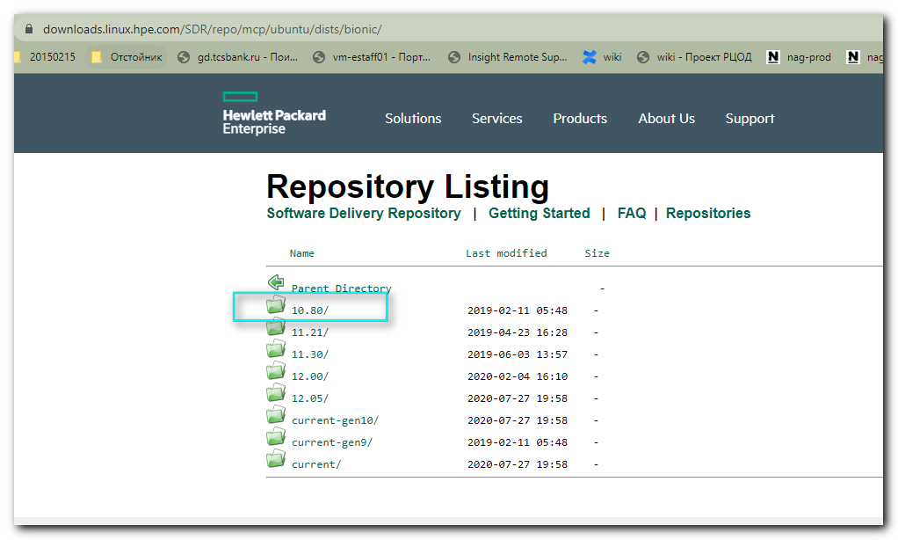

https://downloads.linux.hpe.com/SDR/repo/mcp/pool/non-free/
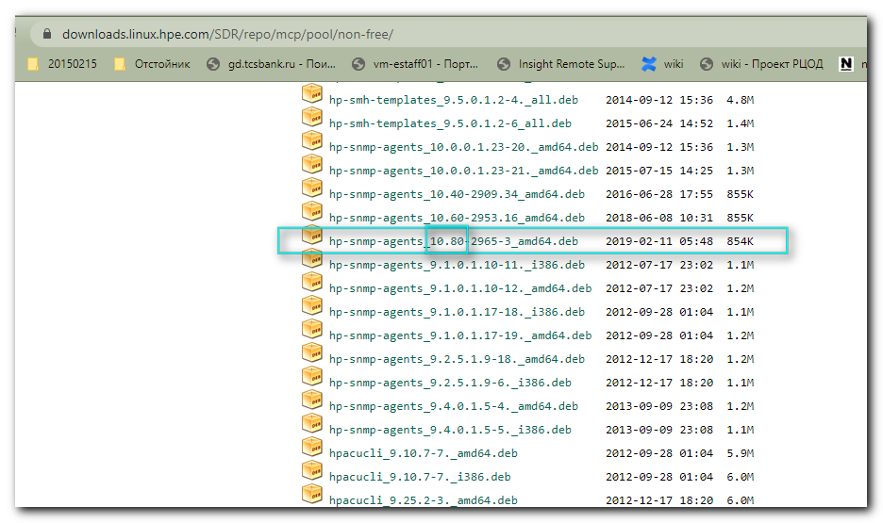
#
# For other repository strings - there are no found appropriate packages.
# Only for version 10.80 we have, what we want.
#
root@ds-spl-indexer:~# apt-cache search hp-snmp
php-snmp - SNMP module for PHP [default]
php7.2-snmp - SNMP module for PHP
root@ds-spl-indexer:~#

#
# This is right choice. Only for written version exists packages, that I wanted to install.
#
root@ds-spl-indexer:~# cat /etc/apt/sources.list.d/tcs-hp.list
# HPE Management Component Pack
# deb http://downloads.linux.hpe.com/SDR/repo/mcp dist/project_ver non-free

#deb http://repo-linux.tcsbank.ru/repository/hp/SDR/repo/mcp bionic/current non-free
# https://downloads.linux.hpe.com/SDR/repo/mcp/ubuntu/dists/
#deb http://repo-linux.tcsbank.ru/repository/hp/SDR/repo/mcp/ubuntu 18.04-LTS/current non-free
#deb http://repo-linux.tcsbank.ru/repository/hp/SDR/repo/mcp/ubuntu bionic/current non-free
#deb http://repo-linux.tcsbank.ru/repository/hp/SDR/repo/mcp/debian bionic/current non-free
#deb http://repo-linux.tcsbank.ru/repository/hp/SDR/repo/mcp/ubuntu bionic/12.05 non-free
deb http://repo-linux.tcsbank.ru/repository/hp/SDR/repo/mcp/ubuntu bionic/10.80 non-free
root@ds-spl-indexer:~#

root@ds-spl-indexer:~# apt-get clean && apt-get update
Hit:1 http://repo-linux.tcsbank.ru/ubuntu bionic InRelease
Hit:2 http://repo-linux.tcsbank.ru/ubuntu bionic-updates InRelease
Hit:3 http://repo-linux.tcsbank.ru/ubuntu bionic-backports InRelease
Hit:4 http://repo-linux.tcsbank.ru/ubuntu bionic-security InRelease
Ign:5 http://repo-linux.tcsbank.ru/repository/hp/SDR/repo/mcp/ubuntu bionic/10.80 InRelease
Hit:6 http://repo-linux.tcsbank.ru/puppetlabs/apt bionic InRelease
Get:7 http://repo-linux.tcsbank.ru/repository/hp/SDR/repo/mcp/ubuntu bionic/10.80 Release [6,051 B]
Get:8 http://repo-linux.tcsbank.ru/repository/hp/SDR/repo/mcp/ubuntu bionic/10.80 Release.gpg [490 B]
Get:9 http://repo-linux.tcsbank.ru/repository/hp/SDR/repo/mcp/ubuntu bionic/10.80/non-free i386 Packages [579 B]
Get:10 http://repo-linux.tcsbank.ru/repository/hp/SDR/repo/mcp/ubuntu bionic/10.80/non-free amd64 Packages [3,075 B]
Fetched 10.2 kB in 1s (17.2 kB/s)
Reading package lists... Done
root@ds-spl-indexer:~#

#
# This is what I wanted to install.
#
root@ds-spl-indexer:~# apt-get install hp-health hponcfg hp-snmp-agents hpsmh hp-smh-templates hp-ams
Reading package lists... Done
Building dependency tree
Reading state information... Done
The following packages were automatically installed and are no longer required:
facter fonts-lato hiera javascript-common libboost-locale1.65.1 libboost-log1.65.1 libboost-program-options1.65.1 libboost-regex1.65.1 libboost-thread1.65.1
libcpp-hocon0.1.6 libfacter3.10.0 libjs-jquery libleatherman-data libleatherman1.4.0 libopts25 libruby2.5 libyaml-cpp0.5v5 python-argcomplete python-ipaddr rake ruby
ruby-augeas ruby-deep-merge ruby-did-you-mean ruby-json ruby-minitest ruby-net-telnet ruby-power-assert ruby-selinux ruby-shadow ruby-test-unit ruby2.5
rubygems-integration sntp
Use 'apt autoremove' to remove them.
The following additional packages will be installed:
binutils binutils-common binutils-x86-64-linux-gnu lib32gcc1 libbinutils libc6-i386 snmpd xsltproc
Suggested packages:
binutils-doc snmptrapd
The following NEW packages will be installed:
binutils binutils-common binutils-x86-64-linux-gnu hp-ams hp-health hp-smh-templates hp-snmp-agents hponcfg hpsmh lib32gcc1 libbinutils libc6-i386 snmpd xsltproc
0 upgraded, 14 newly installed, 0 to remove and 23 not upgraded.
Need to get 25.0 MB of archives.
After this operation, 94.5 MB of additional disk space will be used.
Do you want to continue? [Y/n] Y
Get:1 http://repo-linux.tcsbank.ru/ubuntu bionic-updates/main amd64 binutils-common amd64 2.30-21ubuntu1~18.04.4 [196 kB]
Get:2 http://repo-linux.tcsbank.ru/ubuntu bionic-updates/main amd64 libbinutils amd64 2.30-21ubuntu1~18.04.4 [488 kB]
Get:3 http://repo-linux.tcsbank.ru/ubuntu bionic-updates/main amd64 binutils-x86-64-linux-gnu amd64 2.30-21ubuntu1~18.04.4 [1,839 kB]
Get:4 http://repo-linux.tcsbank.ru/ubuntu bionic-updates/main amd64 binutils amd64 2.30-21ubuntu1~18.04.4 [3,392 B]
Get:5 http://repo-linux.tcsbank.ru/repository/hp/SDR/repo/mcp/ubuntu bionic/10.80/non-free amd64 hp-ams amd64 2.8.3-3056.1ubuntu16 [550 kB]
Get:6 http://repo-linux.tcsbank.ru/ubuntu bionic-updates/main amd64 libc6-i386 amd64 2.27-3ubuntu1.2 [2,650 kB]
Get:7 http://repo-linux.tcsbank.ru/ubuntu bionic-updates/main amd64 lib32gcc1 amd64 1:8.4.0-1ubuntu1~18.04 [48.1 kB]
Get:8 http://repo-linux.tcsbank.ru/repository/hp/SDR/repo/mcp/ubuntu bionic/10.80/non-free amd64 hp-health amd64 10.80-1874.10 [463 kB]
Get:9 http://repo-linux.tcsbank.ru/ubuntu bionic-updates/main amd64 snmpd amd64 5.7.3+dfsg-1.8ubuntu3.3 [57.0 kB]
Get:10 http://repo-linux.tcsbank.ru/repository/hp/SDR/repo/mcp/ubuntu bionic/10.80/non-free amd64 hp-snmp-agents amd64 10.80-2965-3 [875 kB]
Get:11 http://repo-linux.tcsbank.ru/repository/hp/SDR/repo/mcp/ubuntu bionic/10.80/non-free amd64 hpsmh amd64 7.6.1-9.1-1. [13.7 MB]
Get:12 http://repo-linux.tcsbank.ru/repository/hp/SDR/repo/mcp/ubuntu bionic/10.80/non-free amd64 hp-smh-templates all 10.60.2-2. [4,068 kB]
Get:13 http://repo-linux.tcsbank.ru/ubuntu bionic-updates/main amd64 xsltproc amd64 1.1.29-5ubuntu0.2 [14.0 kB]
Get:14 http://repo-linux.tcsbank.ru/repository/hp/SDR/repo/mcp/ubuntu bionic/10.80/non-free amd64 hponcfg amd64 5.3.0.0-5 [50.6 kB]
Fetched 25.0 MB in 1min 13s (342 kB/s)
Preconfiguring packages ...
Selecting previously unselected package binutils-common:amd64.
(Reading database ... 125507 files and directories currently installed.)
Preparing to unpack .../00-binutils-common_2.30-21ubuntu1~18.04.4_amd64.deb ...
Unpacking binutils-common:amd64 (2.30-21ubuntu1~18.04.4) ...
Selecting previously unselected package libbinutils:amd64.
Preparing to unpack .../01-libbinutils_2.30-21ubuntu1~18.04.4_amd64.deb ...
Unpacking libbinutils:amd64 (2.30-21ubuntu1~18.04.4) ...
Selecting previously unselected package binutils-x86-64-linux-gnu.
Preparing to unpack .../02-binutils-x86-64-linux-gnu_2.30-21ubuntu1~18.04.4_amd64.deb ...
Unpacking binutils-x86-64-linux-gnu (2.30-21ubuntu1~18.04.4) ...
Selecting previously unselected package binutils.
Preparing to unpack .../03-binutils_2.30-21ubuntu1~18.04.4_amd64.deb ...
Unpacking binutils (2.30-21ubuntu1~18.04.4) ...
Selecting previously unselected package hp-ams.
Preparing to unpack .../04-hp-ams_2.8.3-3056.1ubuntu16_amd64.deb ...
Unpacking hp-ams (2.8.3-3056.1ubuntu16) ...
Selecting previously unselected package libc6-i386.
Preparing to unpack .../05-libc6-i386_2.27-3ubuntu1.2_amd64.deb ...
Unpacking libc6-i386 (2.27-3ubuntu1.2) ...
Selecting previously unselected package lib32gcc1.
Preparing to unpack .../06-lib32gcc1_1%3a8.4.0-1ubuntu1~18.04_amd64.deb ...
Unpacking lib32gcc1 (1:8.4.0-1ubuntu1~18.04) ...
Selecting previously unselected package hp-health.
Preparing to unpack .../07-hp-health_10.80-1874.10_amd64.deb ...
Unpacking hp-health (10.80-1874.10) ...
Selecting previously unselected package snmpd.
Preparing to unpack .../08-snmpd_5.7.3+dfsg-1.8ubuntu3.3_amd64.deb ...
Unpacking snmpd (5.7.3+dfsg-1.8ubuntu3.3) ...
Selecting previously unselected package hp-snmp-agents.
Preparing to unpack .../09-hp-snmp-agents_10.80-2965-3_amd64.deb ...
Unpacking hp-snmp-agents (10.80-2965-3) ...
Selecting previously unselected package hpsmh.
Preparing to unpack .../10-hpsmh_7.6.1-9.1-1._amd64.deb ...
Unpacking hpsmh (7.6.1-9.1-1.) ...
Selecting previously unselected package hp-smh-templates.
Preparing to unpack .../11-hp-smh-templates_10.60.2-2._all.deb ...
Unpacking hp-smh-templates (10.60.2-2.) ...
Selecting previously unselected package xsltproc.
Preparing to unpack .../12-xsltproc_1.1.29-5ubuntu0.2_amd64.deb ...
Unpacking xsltproc (1.1.29-5ubuntu0.2) ...
Selecting previously unselected package hponcfg.
Preparing to unpack .../13-hponcfg_5.3.0.0-5_amd64.deb ...
Unpacking hponcfg (5.3.0.0-5) ...
Setting up snmpd (5.7.3+dfsg-1.8ubuntu3.3) ...
adduser: Warning: The home directory `/var/lib/snmp' does not belong to the user you are currently creating.
Created symlink /etc/systemd/system/multi-user.target.wants/snmpd.service в†’ /lib/systemd/system/snmpd.service.
Setting up xsltproc (1.1.29-5ubuntu0.2) ...
Setting up libc6-i386 (2.27-3ubuntu1.2) ...
Setting up hpsmh (7.6.1-9.1-1.) ...
Adding group `hpsmh' (GID 122) ...
Done.
Setting up binutils-common:amd64 (2.30-21ubuntu1~18.04.4) ...
Setting up hp-ams (2.8.3-3056.1ubuntu16) ...
Job for hp-ams.service failed because the control process exited with error code.
See "systemctl status hp-ams.service" and "journalctl -xe" for details.
invoke-rc.d: initscript hp-ams, action "start" failed.
в—Џ hp-ams.service - LSB: HP AMS helper
Loaded: loaded (/etc/init.d/hp-ams; generated)
Active: failed (Result: exit-code) since Tue 2020-08-25 14:58:25 MSK; 7ms ago
Docs: man:systemd-sysv-generator(8)
Process: 19100 ExecStart=/etc/init.d/hp-ams start (code=exited, status=1/FAILURE)

Aug 25 14:58:24 ds-spl-indexer.tcsbank.ru systemd[1]: Starting LSB: HP AMS helper...
Aug 25 14:58:25 ds-spl-indexer.tcsbank.ru hp-ams[19100]: This program requires the host to have a HP Integrated Lights Out 4 (iLO 4) BMC
Aug 25 14:58:25 ds-spl-indexer.tcsbank.ru systemd[1]: hp-ams.service: Control process exited, code=exited status=1
Aug 25 14:58:25 ds-spl-indexer.tcsbank.ru systemd[1]: hp-ams.service: Failed with result 'exit-code'.
Aug 25 14:58:25 ds-spl-indexer.tcsbank.ru systemd[1]: Failed to start LSB: HP AMS helper.
dpkg: error processing package hp-ams (--configure):
installed hp-ams package post-installation script subprocess returned error exit status 1
Setting up lib32gcc1 (1:8.4.0-1ubuntu1~18.04) ...
Setting up libbinutils:amd64 (2.30-21ubuntu1~18.04.4) ...
Setting up binutils-x86-64-linux-gnu (2.30-21ubuntu1~18.04.4) ...
Setting up binutils (2.30-21ubuntu1~18.04.4) ...
Setting up hp-health (10.80-1874.10) ...
Setting up hponcfg (5.3.0.0-5) ...
Setting up hp-snmp-agents (10.80-2965-3) ...
Setting up hp-smh-templates (10.60.2-2.) ...
visudo: /etc/sudoers.tmp unchanged
Processing triggers for libc-bin (2.27-3ubuntu1.2) ...
Processing triggers for systemd (237-3ubuntu10.42) ...
Processing triggers for man-db (2.8.3-2ubuntu0.1) ...
Processing triggers for ureadahead (0.100.0-21) ...
ureadahead will be reprofiled on next reboot
Errors were encountered while processing:
hp-ams
E: Sub-process /usr/bin/dpkg returned an error code (1)
root@ds-spl-indexer:~#

................................................................................

#
# Here was entered some shit only to create snmp.cfg file.
#
root@ds-spl-indexer:~# hpsnmpconfig

This configuration script will configure SNMP to integrate with the HPE SIM and
the HPE System Management Homepage by editting the snmpd.conf file. The HP-SNMP-Agents can also exist in a more secure
SNMP environment (e.g. VACM) that you have previously configured. See the
hp-snmp-agents(4) man page for specific details on how to configure the VACM entries
in the 'snmpd.conf' file. You may press <ctrl+c> now to exit now if needed.

Do you wish to use an existing snmpd.conf (y/n) (Blank is n): n

You will now be asked a series of SNMP configuration questions. How you answer
these question will affect the way SNMP behaves. Configuring SNMP could have
security implications on your system. If you are not sure how to answer a
question, you can abort by pressing <Ctrl-c> and no changes will be made to
your SNMP configuration.

Enter the localhost SNMP Read/Write community string
(one word, required, no default):
Re-enter the same input to confirm:
ERROR: inputs mismatch! Press ENTER to try again.

You will now be asked a series of SNMP configuration questions. How you answer
these question will affect the way SNMP behaves. Configuring SNMP could have
security implications on your system. If you are not sure how to answer a
question, you can abort by pressing <Ctrl-c> and no changes will be made to
your SNMP configuration.

Enter the localhost SNMP Read/Write community string
(one word, required, no default):
Re-enter the same input to confirm:
ACCEPTED: inputs match!

Enter localhost SNMP Read Only community string
(one word, Blank to skip):
Re-enter the same input to confirm:
ACCEPTED: inputs match!

Enter Read/Write Authorized Management Station IP or DNS name
(Blank to skip):
Enter Read Only Authorized Management Station IP or DNS name
(Blank to skip):
Enter default SNMP trap community string
(One word; Blank to skip):
Trap sinks are set up like this:
trapsink localhost public
Do you wish to change this (y/n) (Blank is n): n
Enter system contact information
(Name, phone, room, etc; Blank to skip):
Enter system location information
(Building, room, etc; Blank to skip):

==============================================================================
NOTE: New snmpd.conf entries were added to the top of /etc/snmp/snmpd.conf
==============================================================================
snmpd is started

root@ds-spl-indexer:~#

root@ds-spl-indexer:~# mkdir -p ~/work/20200825-1506
root@ds-spl-indexer:~# cp /etc/snmp/snmpd.conf ~/work/20200825-1506/
root@ds-spl-indexer:~# vim /etc/snmp/snmpd.conf
root@ds-spl-indexer:~# cat /etc/snmp/snmpd.conf
# Following entries were added by HPE Insight Management Agents at
# Fri Dec 22 04:49:24 EST 2017
dlmod cmaX /usr/lib/libcmaX64.so
rwcommunity tcspub 127.0.0.1
rocommunity tcspub 127.0.0.1
rwcommunity tcspub 10.218.71.11
rocommunity tcspub 172.16.1.115
rocommunity tcspub 172.16.1.117
rocommunity tcspub 172.16.1.6
rocommunity tcspub 172.16.1.11
rocommunity tcspub 10.217.50.167
rocommunity tcspub 10.216.43.159
trapcommunity tcspub
trapsink tcspub tcspub
syscontact Root <root@localhost> (configure /etc/snmp/snmp.local.conf)
syslocation Unknown (edit /etc/snmp/snmpd.conf)

# ---------------------- END --------------------
agentAddress udp:161
group notConfigGroup v1 notConfigUsergroup notConfigGroup v2c
notConfigUser
view all included .1
view systemview included .1.3.6.1.2.1.1
view systemview included .1.3.6.1.2.1.25.1.1
access notConfigGroup "" any noauth exact all none none
dontLogTCPWrappersConnects yes
smuxpeer .1.3.6.1.4.1.674.10892.1
com2sec notConfigUser default tcspub
Trapsink 10.216.43.159 tcspub
includeDir /etc/snmp/config.d

root@ds-spl-indexer:~#

................................................................................
root@ds-spl-indexer:~# systemctl status hp-snmp-agents.service
в—Џ hp-snmp-agents.service - LSB: hp SNMP Agents.
Loaded: loaded (/etc/init.d/hp-snmp-agents; generated)
Active: active (running) since Tue 2020-08-25 14:58:31 MSK; 10min ago
Docs: man:systemd-sysv-generator(8)
Tasks: 18 (limit: 4915)
CGroup: /system.slice/hp-snmp-agents.service
в”њв”Ђ19480 cmahealthd -p 30 -s OK -t OK -i -l /var/log/hp-snmp-agents/cma.log
в”њв”Ђ19503 cmastdeqd -p 30 -l /var/log/hp-snmp-agents/cma.log
в”њв”Ђ19525 cmahostd -p 15 -s OK -l /var/log/hp-snmp-agents/cma.log
в”њв”Ђ19544 cmathreshd -p 5 -s OK -l /var/log/hp-snmp-agents/cma.log
в”њв”Ђ19579 cmasm2d -p 30 -l /var/log/hp-snmp-agents/cma.log
в”њв”Ђ19598 cmaperfd -p 30 -s OK -l /var/log/hp-snmp-agents/cma.log
в”њв”Ђ19619 cmapeerd -l /var/log/hp-snmp-agents/cma.log
в”њв”Ђ19641 cmaeventd -p 15 -l /var/log/hp-snmp-agents/cma.log
в”њв”Ђ19661 cmafcad -p 15 -s OK -l /var/log/hp-snmp-agents/cma.log
в”њв”Ђ19682 cmasasd -p 15 -s OK -l /var/log/hp-snmp-agents/cma.log
в”њв”Ђ19705 cmaidad -p 15 -s OK -l /var/log/hp-snmp-agents/cma.log
в”њв”Ђ19725 cmaided -p 15 -s OK -l /var/log/hp-snmp-agents/cma.log
в”њв”Ђ19747 cmascsid -p 15 -s OK -l /var/log/hp-snmp-agents/cma.log
в”њв”Ђ19773 cmanicd -l /var/log/hp-snmp-agents/cma.log
в””в”Ђ22127 cmasm2d -p 30 -l /var/log/hp-snmp-agents/cma.log

Aug 25 14:58:26 ds-spl-indexer.tcsbank.ru hp-snmp-agents[19447]: Starting IDA agent (cmaidad): [ SUCCESS ]
Aug 25 14:58:26 ds-spl-indexer.tcsbank.ru hp-snmp-agents[19447]:
Aug 25 14:58:26 ds-spl-indexer.tcsbank.ru hp-snmp-agents[19447]: Starting IDE agent (cmaided): [ SUCCESS ]
Aug 25 14:58:26 ds-spl-indexer.tcsbank.ru hp-snmp-agents[19447]:
Aug 25 14:58:26 ds-spl-indexer.tcsbank.ru hp-snmp-agents[19447]: Starting SCSI agent (cmascsid): [ SUCCESS ]
Aug 25 14:58:26 ds-spl-indexer.tcsbank.ru hp-snmp-agents[19447]:
Aug 25 14:58:31 ds-spl-indexer.tcsbank.ru hp-snmp-agents[19447]: Starting NIC Agent Daemon (cmanicd): [ SUCCESS ]
Aug 25 14:58:31 ds-spl-indexer.tcsbank.ru hp-snmp-agents[19447]: WARNING:hp-snmp-agents is not configured.
Aug 25 14:58:31 ds-spl-indexer.tcsbank.ru hp-snmp-agents[19447]: You must type '/sbin/hpsnmpconfig' as 'root' user to configure agents.
Aug 25 14:58:31 ds-spl-indexer.tcsbank.ru systemd[1]: Started LSB: hp SNMP Agents..
root@ds-spl-indexer:~# systemctl stop hp-snmp-agents.service
root@ds-spl-indexer:~# systemctl start hp-snmp-agents.service
root@ds-spl-indexer:~#

root@ds-spl-indexer:~# systemctl status hp-snmp-agents.service
в—Џ hp-snmp-agents.service - LSB: hp SNMP Agents.
Loaded: loaded (/etc/init.d/hp-snmp-agents; generated)
Active: active (running) since Tue 2020-08-25 15:09:44 MSK; 27s ago
Docs: man:systemd-sysv-generator(8)
Process: 23059 ExecStop=/etc/init.d/hp-snmp-agents stop (code=exited, status=0/SUCCESS)
Process: 24213 ExecStart=/etc/init.d/hp-snmp-agents start (code=exited, status=0/SUCCESS)
Tasks: 18 (limit: 4915)
CGroup: /system.slice/hp-snmp-agents.service
в”њв”Ђ24241 cmahealthd -p 30 -s OK -t OK -i -l /var/log/hp-snmp-agents/cma.log
в”њв”Ђ24266 cmastdeqd -p 30 -l /var/log/hp-snmp-agents/cma.log
в”њв”Ђ24288 cmahostd -p 15 -s OK -l /var/log/hp-snmp-agents/cma.log
в”њв”Ђ24307 cmathreshd -p 5 -s OK -l /var/log/hp-snmp-agents/cma.log
в”њв”Ђ24342 cmasm2d -p 30 -l /var/log/hp-snmp-agents/cma.log
в”њв”Ђ24344 cmasm2d -p 30 -l /var/log/hp-snmp-agents/cma.log
в”њв”Ђ24383 cmaperfd -p 30 -s OK -l /var/log/hp-snmp-agents/cma.log
в”њв”Ђ24404 cmapeerd -l /var/log/hp-snmp-agents/cma.log
в”њв”Ђ24424 cmaeventd -p 15 -l /var/log/hp-snmp-agents/cma.log
в”њв”Ђ24448 cmafcad -p 15 -s OK -l /var/log/hp-snmp-agents/cma.log
в”њв”Ђ24469 cmasasd -p 15 -s OK -l /var/log/hp-snmp-agents/cma.log
в”њв”Ђ24491 cmaidad -p 15 -s OK -l /var/log/hp-snmp-agents/cma.log
в”њв”Ђ24511 cmaided -p 15 -s OK -l /var/log/hp-snmp-agents/cma.log
в”њв”Ђ24533 cmascsid -p 15 -s OK -l /var/log/hp-snmp-agents/cma.log
в””в”Ђ24559 cmanicd -l /var/log/hp-snmp-agents/cma.log

Aug 25 15:09:39 ds-spl-indexer.tcsbank.ru hp-snmp-agents[24213]: Starting SAS agent (cmasasd): [ SUCCESS ]
Aug 25 15:09:39 ds-spl-indexer.tcsbank.ru hp-snmp-agents[24213]:
Aug 25 15:09:39 ds-spl-indexer.tcsbank.ru hp-snmp-agents[24213]: Starting IDA agent (cmaidad): [ SUCCESS ]
Aug 25 15:09:39 ds-spl-indexer.tcsbank.ru hp-snmp-agents[24213]:
Aug 25 15:09:39 ds-spl-indexer.tcsbank.ru hp-snmp-agents[24213]: Starting IDE agent (cmaided): [ SUCCESS ]
Aug 25 15:09:39 ds-spl-indexer.tcsbank.ru hp-snmp-agents[24213]:
Aug 25 15:09:39 ds-spl-indexer.tcsbank.ru hp-snmp-agents[24213]: Starting SCSI agent (cmascsid): [ SUCCESS ]
Aug 25 15:09:39 ds-spl-indexer.tcsbank.ru hp-snmp-agents[24213]:
Aug 25 15:09:44 ds-spl-indexer.tcsbank.ru hp-snmp-agents[24213]: Starting NIC Agent Daemon (cmanicd): [ SUCCESS ]
Aug 25 15:09:44 ds-spl-indexer.tcsbank.ru systemd[1]: Started LSB: hp SNMP Agents..
root@ds-spl-indexer:~#

................................................................................
#
# Here I can note, that snmp daemon listen its port only on local interface.
#
root@ds-spl-indexer:~# netstat -nlptu | grep 161
udp 0 0 127.0.0.1:161 0.0.0.0:* 22721/snmpd
root@ds-spl-indexer:~# snmpwalk -v 2c -c tcspub 127.0.0.1 1 | head
iso.3.6.1.2.1.1.1.0 = STRING: "Linux ds-spl-indexer.tcsbank.ru 5.4.0-42-generic #46~18.04.1-Ubuntu SMP Fri Jul 10 07:21:24 UTC 2020 x86_64"
iso.3.6.1.2.1.1.2.0 = OID: iso.3.6.1.4.1.8072.3.2.10
iso.3.6.1.2.1.1.3.0 = Timeticks: (42990) 0:07:09.90
iso.3.6.1.2.1.1.4.0 = STRING: "Me <me@example.org>"
iso.3.6.1.2.1.1.5.0 = STRING: "ds-spl-indexer.tcsbank.ru"
iso.3.6.1.2.1.1.6.0 = STRING: "Sitting on the Dock of the Bay"
iso.3.6.1.2.1.1.7.0 = INTEGER: 72
iso.3.6.1.2.1.1.8.0 = Timeticks: (1) 0:00:00.01
iso.3.6.1.2.1.1.9.1.2.1 = OID: iso.3.6.1.6.3.11.3.1.1
iso.3.6.1.2.1.1.9.1.2.2 = OID: iso.3.6.1.6.3.15.2.1.1
root@ds-spl-indexer:~# ip a | grep -w inet
inet 127.0.0.1/8 scope host lo
inet 10.216.103.42/24 brd 10.216.103.255 scope global enp4s0f1.3903
root@ds-spl-indexer:~# snmpwalk -v 2c -c tcspub 10.216.103.42 1 | head
Timeout: No Response from 10.216.103.42
root@ds-spl-indexer:~#

# And of course there is no connectin from nag-tst
[root@vd-nag4-tst-1 objects]# check_hpasm --hostname ds-spl-indexer.tcsbank.ru --community tcspub -v --perfdata=short | head
CRITICAL - could not contact snmp agent, wrong device

[root@vd-nag4-tst-1 objects]# host ds-spl-indexer.tcsbank.ru
ds-spl-indexer.tcsbank.ru has address 10.216.103.42
[root@vd-nag4-tst-1 objects]#

................................................................................
# Let’s restart snmp daemon.
#
root@ds-spl-indexer:~# systemctl status snmpd
в—Џ snmpd.service - Simple Network Management Protocol (SNMP) Daemon.
Loaded: loaded (/lib/systemd/system/snmpd.service; enabled; vendor preset: enabled)
Active: active (running) since Tue 2020-08-25 15:04:17 MSK; 16min ago
Process: 22720 ExecStartPre=/bin/mkdir -p /var/run/agentx (code=exited, status=0/SUCCESS)
Main PID: 22721 (snmpd)
Tasks: 1 (limit: 4915)
CGroup: /system.slice/snmpd.service
в””в”Ђ22721 /usr/sbin/snmpd -Lsd -Lf /dev/null -u Debian-snmp -g Debian-snmp -I -smux mteTrigger mteTriggerConf -f

Aug 25 15:20:15 ds-spl-indexer.tcsbank.ru snmpd[22721]: Connection from UDP: [127.0.0.1]:40889->[127.0.0.1]:161
Aug 25 15:20:15 ds-spl-indexer.tcsbank.ru snmpd[22721]: Connection from UDP: [127.0.0.1]:40889->[127.0.0.1]:161
Aug 25 15:20:15 ds-spl-indexer.tcsbank.ru snmpd[22721]: Connection from UDP: [127.0.0.1]:33361->[127.0.0.1]:161
Aug 25 15:20:15 ds-spl-indexer.tcsbank.ru snmpd[22721]: Connection from UDP: [127.0.0.1]:47495->[127.0.0.1]:161
Aug 25 15:20:15 ds-spl-indexer.tcsbank.ru snmpd[22721]: Connection from UDP: [127.0.0.1]:47495->[127.0.0.1]:161
Aug 25 15:20:15 ds-spl-indexer.tcsbank.ru snmpd[22721]: Connection from UDP: [127.0.0.1]:51100->[127.0.0.1]:161
Aug 25 15:20:15 ds-spl-indexer.tcsbank.ru snmpd[22721]: Connection from UDP: [127.0.0.1]:52298->[127.0.0.1]:161
Aug 25 15:20:15 ds-spl-indexer.tcsbank.ru snmpd[22721]: Connection from UDP: [127.0.0.1]:52298->[127.0.0.1]:161
Aug 25 15:20:15 ds-spl-indexer.tcsbank.ru snmpd[22721]: Connection from UDP: [127.0.0.1]:57948->[127.0.0.1]:161
Aug 25 15:20:17 ds-spl-indexer.tcsbank.ru snmpd[22721]: error on subcontainer 'ia_addr' insert (-1)
root@ds-spl-indexer:~# systemctl stop snmpd
root@ds-spl-indexer:~# systemctl start snmpd
root@ds-spl-indexer:~# systemctl status snmpd
в—Џ snmpd.service - Simple Network Management Protocol (SNMP) Daemon.
Loaded: loaded (/lib/systemd/system/snmpd.service; enabled; vendor preset: enabled)
Active: active (running) since Tue 2020-08-25 15:20:43 MSK; 10s ago
Process: 8622 ExecStartPre=/bin/mkdir -p /var/run/agentx (code=exited, status=0/SUCCESS)
Main PID: 8627 (snmpd)
Tasks: 1 (limit: 4915)
CGroup: /system.slice/snmpd.service
в””в”Ђ8627 /usr/sbin/snmpd -Lsd -Lf /dev/null -u Debian-snmp -g Debian-snmp -I -smux mteTrigger mteTriggerConf -f

Aug 25 15:20:43 ds-spl-indexer.tcsbank.ru snmpd[8627]: cmaX: subMIB 10 will be sent on port 25376 to hp Advanced Server Management_Peer
Aug 25 15:20:43 ds-spl-indexer.tcsbank.ru snmpd[8627]: cmaX: subMIB 11 will be sent on port 25376 to hp Advanced Server Management_Peer
Aug 25 15:20:43 ds-spl-indexer.tcsbank.ru snmpd[8627]: cmaX: subMIB 14 will be sent on port 25376 to hp Advanced Server Management_Peer
Aug 25 15:20:43 ds-spl-indexer.tcsbank.ru snmpd[8627]: cmaX: subMIB 15 will be sent on port 25376 to hp Advanced Server Management_Peer
Aug 25 15:20:43 ds-spl-indexer.tcsbank.ru snmpd[8627]: cmaX: subMIB 16 will be sent on port 25376 to hp Advanced Server Management_Peer
Aug 25 15:20:43 ds-spl-indexer.tcsbank.ru snmpd[8627]: cmaX: subMIB 21 will be sent on port 25376 to hp Advanced Server Management_Peer
Aug 25 15:20:43 ds-spl-indexer.tcsbank.ru snmpd[8627]: cmaX: subMIB 22 will be sent on port 25376 to hp Advanced Server Management_Peer
Aug 25 15:20:43 ds-spl-indexer.tcsbank.ru snmpd[8627]: cmaX: subMIB 18 handler has disconnected
Aug 25 15:20:43 ds-spl-indexer.tcsbank.ru snmpd[8627]: cmaX: subMIB 23 will be sent on port 25376 to hp Advanced Server Management_Peer
Aug 25 15:20:43 ds-spl-indexer.tcsbank.ru snmpd[8627]: cmaX: subMIB 18 will be sent on port 25393 to cpqnicd
root@ds-spl-indexer:~#

# And here is much better - snmp daemon started listen on all interfaces.
# But access from local host is still unavailable to this outside ip address - as it was defined in snmpd.conf file. And this is not a trouble because at the end - we need to get access from nag-tst to this ouside ip-address.
root@ds-spl-indexer:~# netstat -nlptu | grep 161
udp 0 0 0.0.0.0:161 0.0.0.0:* 8627/snmpd
root@ds-spl-indexer:~# snmpwalk -v 2c -c tcspub 10.216.103.42 1 | head
Timeout: No Response from 10.216.103.42
root@ds-spl-indexer:~#

#
# That's success!!!
# Even if from local host I didn't receve results from snmpwalk, I have gotten it from nagios server.
# And that's exactly what I need!
#
[root@vd-nag4-tst-1 objects]# check_hpasm --hostname ds-spl-indexer.tcsbank.ru --community tcspub -v --perfdata=short | head
OK - System: 'proliant dl380 g7', S/N: 'GB803550KE', ROM: 'P67 08/16/2015', hardware working fine, da: 1 logical drives, 8 physical drives
checking cpus
cpu 0 is ok
cpu 1 is ok
checking power supplies
powersupply 1 is ok
powersupply 2 is ok
checking fans
overall fan status: system=ok, cpu=ok
fan 1 is present, speed is normal, pctmax is 50%, location is value_18, redundance is redundant, partner is 2
[root@vd-nag4-tst-1 objects]#
................................................................................

[root@vd-nag4-tst-1 objects]# pynag list host_name filename where object_type=host and host_name__contains="ds-spl-indexer" --quiet #pynag_host
ds-spl-indexer /usr/local/nagios/etc/objects/servers/dc-m1/linux/security/ds-spl-indexer.cfg
[root@vd-nag4-tst-1 objects]# vim servers/dc-m1/linux/security/ds-spl-indexer.cfg
[root@vd-nag4-tst-1 objects]# tail servers/dc-m1/linux/security/ds-spl-indexer.cfg
contact_groups linux-admins
check_command check_nrpe!check_ntp_time
}
define service{
use hp-health-service
host_name ds-spl-indexer
service_description HP System Health Application
check_command check_hpasm
contact_groups secure-admins, linux-admins
}
[root@vd-nag4-tst-1 objects]#

[root@vd-nag4-tst-1 objects]# git commit --author='Belogrud <s.belogrud@tinkoff.ru>' -m "JIRA#IN-394. Was made server health for this server." servers/dc-m1/linux/security/ds-spl-indexer.cfg
[master 58177c3] JIRA#IN-394. Was made server health for this server.
Author: Belogrud <s.belogrud@tinkoff.ru>
1 files changed, 7 insertions(+), 7 deletions(-)
[root@vd-nag4-tst-1 objects]# git pull && git push
Already up-to-date.
Counting objects: 15, done.
Delta compression using up to 4 threads.
Compressing objects: 100% (8/8), done.
Writing objects: 100% (8/8), 686 bytes, done.
Total 8 (delta 7), reused 0 (delta 0)
To git@vm-gitlab01.tcsbank.ru:nagios-core/nag4-base.git
8295dff..58177c3 master -> master
[root@vd-nag4-tst-1 objects]#

................................................................................
#
# This is not required, as I see.
#
root@ds-spl-indexer:~# systemctl enable hp-snmp-agents.service
hp-snmp-agents.service is not a native service, redirecting to systemd-sysv-install.
Executing: /lib/systemd/systemd-sysv-install enable hp-snmp-agents
root@ds-spl-indexer:~#
................................................................................

